App in a Day

Hands-on Lab Step-by-Step

December 2019

Contents

Importing Module 2 Completed 1

Task 1: Create a new environment 1

Task 2: Import the solution 2

Task 3: Import the application 4

# Importing Module 2 Completed

Follow the steps below, if you did not complete Module 1 or Module 2 and would like to skip to Module 3

## Task 1: Create a new environment

1. Open a new browser tab, navigate to <https://admin.powerapps.com> select **Environments** and click **New Environment**.

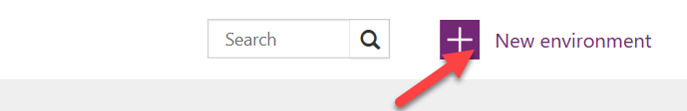

1. Provide an **Environment Name**, select **Region**, select **Environment Type**, and click **Create Environment**.

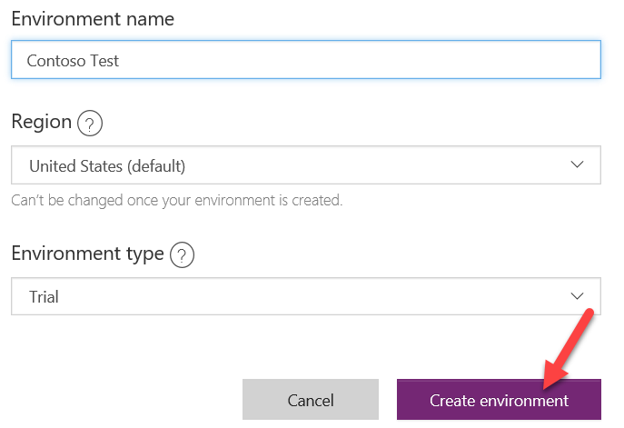

1. Click **Create database**.

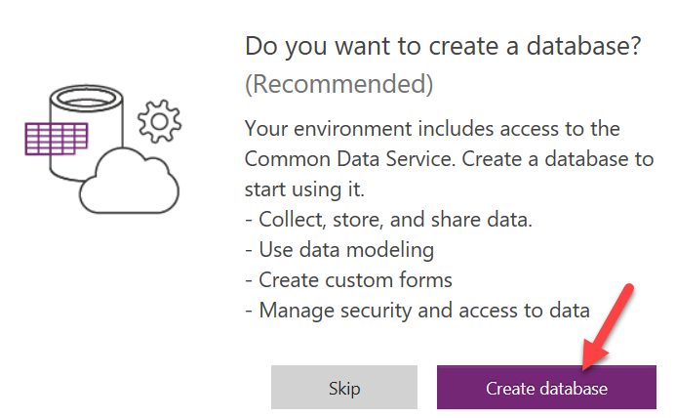

1. Select **Currency** and **Language**, and then click **Create database**.

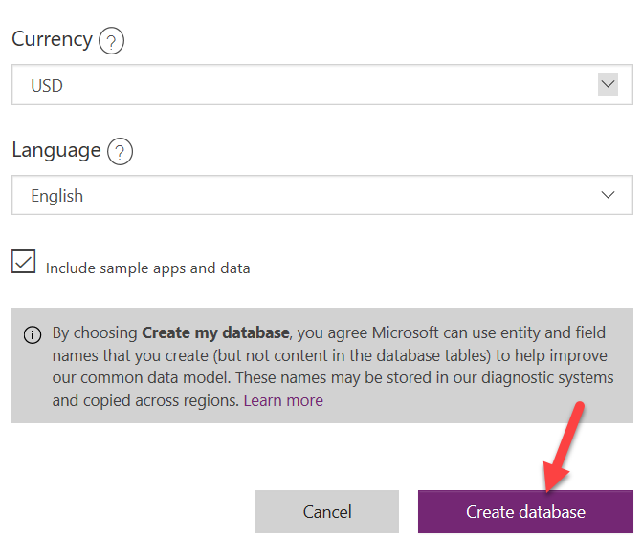

Wait for the database to be created.

## Task 2: Import the solution

In this task, you will import the completed module 2 solution.

1. Navigate to <https://make.powerapps.com/>
2. Ake sure you are in the **Contoso Test** Environment you created.
3. Select **Solutions** and click **Import**.

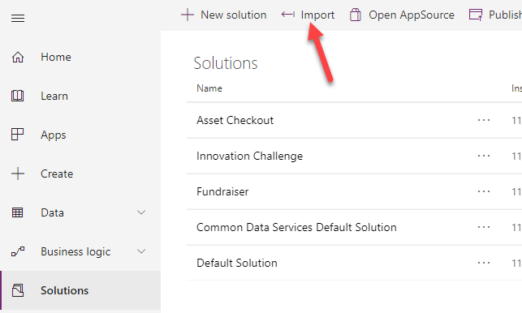

1. Click Browse.

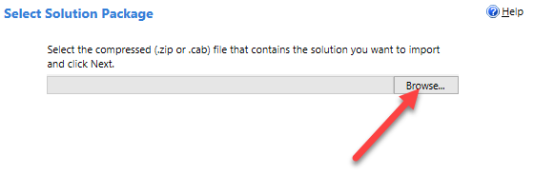

1. Select Mod 2 Completed Solution and click Open.

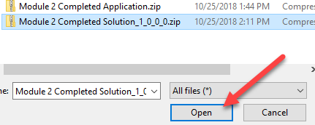

1. Click Next.

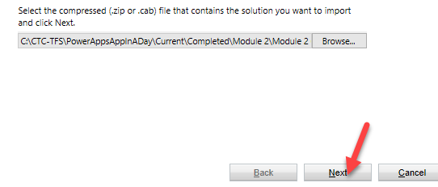

1. Click Next.
2. Click Import.
3. Wait for the import to complete and click Close.

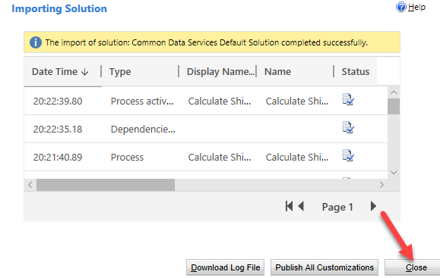

## Task 3: Import the application

In this task, you will import the completed module 2 application.

1. Select **Apps** and click **Import package**.

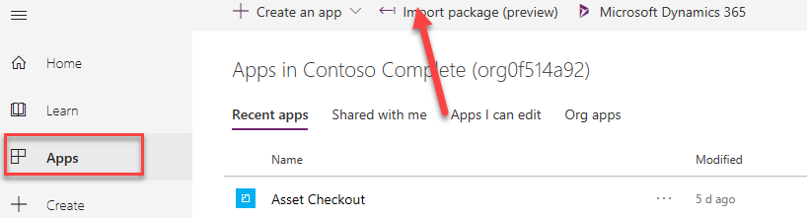

1. Click **Upload**.

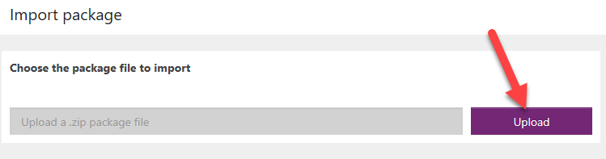

1. Select the Module Completed Application zip file located in Module 2 completed folder and click **Open**.

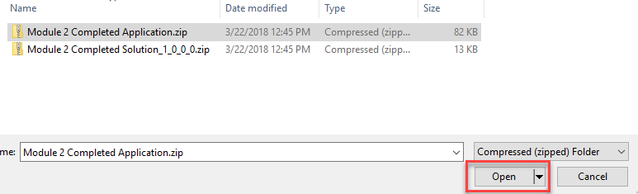

1. Click **Import**.

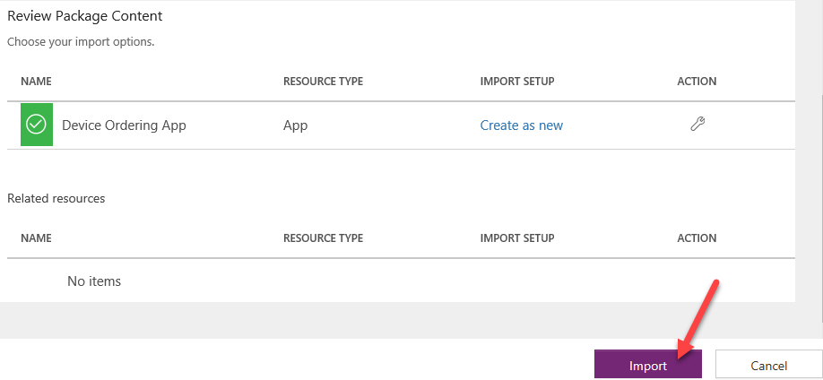

Wait for the application import to complete.

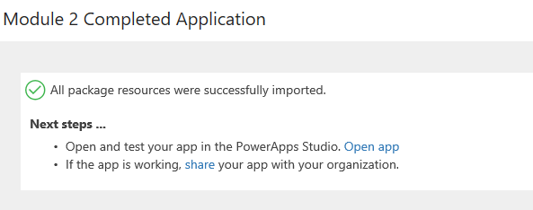

1. Select Apps, click on the … button of the application you imported and click **Play**.

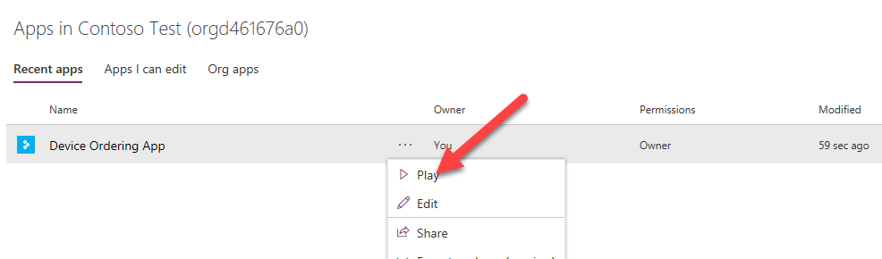

1. Click **Allow**.

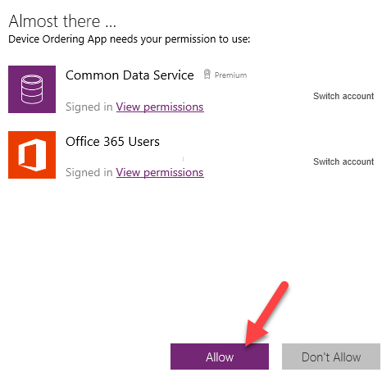

1. Select a few devices and click **Compare**.

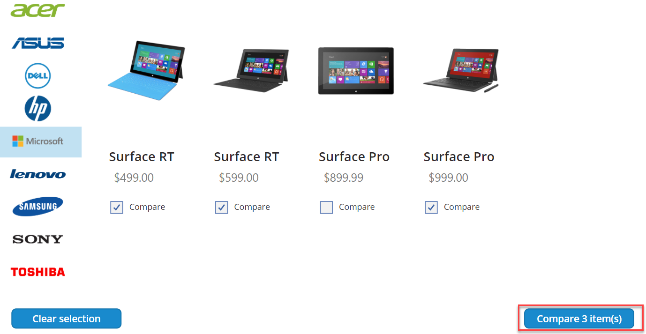

1. Select one of the devices and click **Submit**.

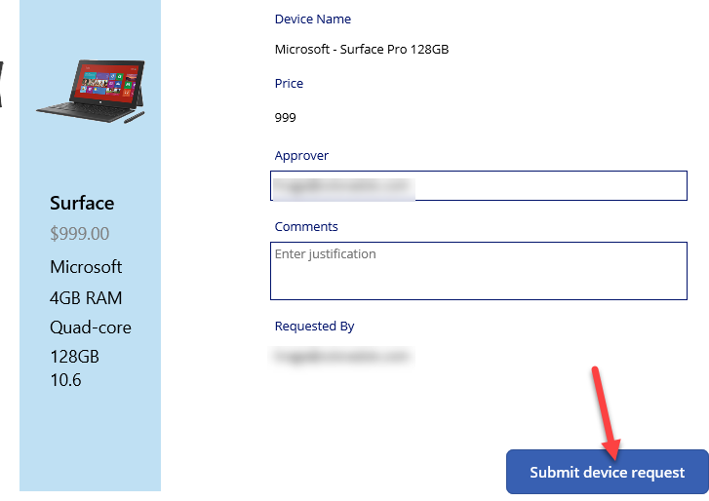

1. Click **OK**.

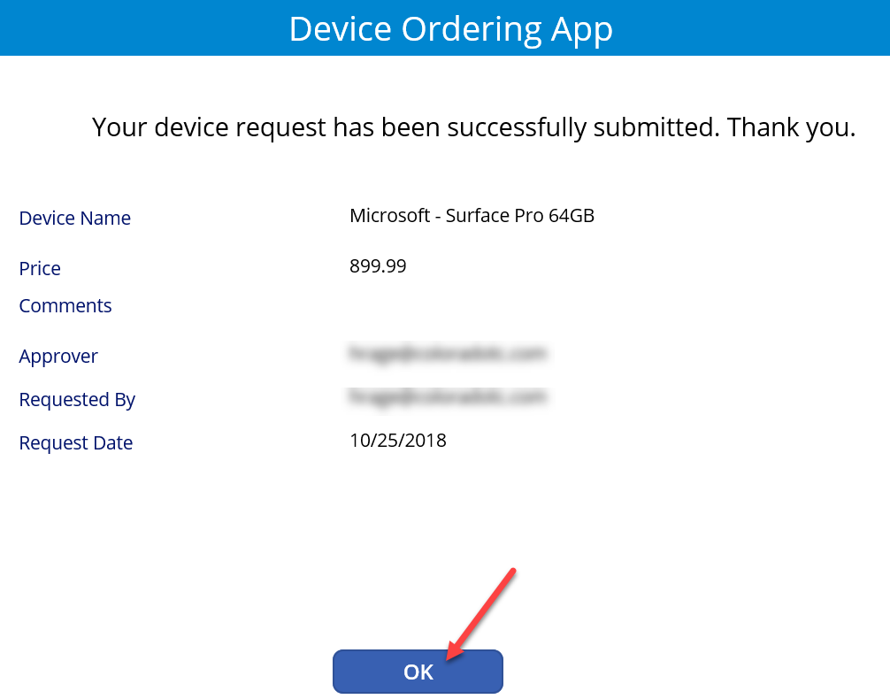

1. Close the application.
2. Expand **Data**, select **Entities**, search for **Device Order** and click on it.

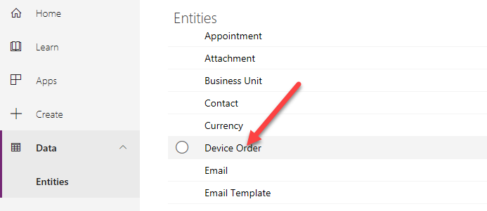

1. Select the Data tab and make sure you have at least one record in the table.

